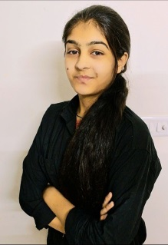**Mitali Sharma**

**Email :** [smitali114@gmail.com](mailto:smitali114@gmail.com)

**Phone no :** +(91) 8118841801

**Address :** C-318, Unique Builder, Near Ryan International School ,

Maharana Pratap Nagar, Ajmer.

[](https://www.linkedin.com/in/mitali-sharma-02389825a?utm_source=share&utm_campaign=share_via&utm_content=profile&utm_medium=android_app) [](https://github.com/mitali-sharma23)

**Technical Skills**

* **Languages:** Java, C++, C
* **Scripting Language:** JavaScript
* **Frontend Technologies:** React JS, Tailwind, HTML, CSS
* **Database Technology:** SQL(Basic)

**Academic Qualification**

* Pursuing – B. Tech(Computer Science) – Aryabhatta College Of Engineering And Research Centre , Ajmer
* XII – H.K.H Public School, Ajmer
* X – Blossom Secondary School, Ajmer

**Experience**

* **Web Developer Intern | CodSoft**

During my time there , I developed a solid understanding of Frontend development principles, improved my skills in JavaScript, and learned best practices in coding – Javascript , CSS , HTML.

**Key Projects**

* **Weather app –** A simple and user-friendly weather app that provides current weather information for any location. The app uses the OpenWeatherMap API to fetch real-time weather data and displays it in clear format – React JS, Tailwind, Javascript.
* **Personal Portfolio –** This websites features a clean and modern design, with easy navigation and clear displays of my projects and skills. It is a platform for me to share my work with others